Name: Arpit Mahalle
Day 19 Assignment output screenshots

Challenge 1:
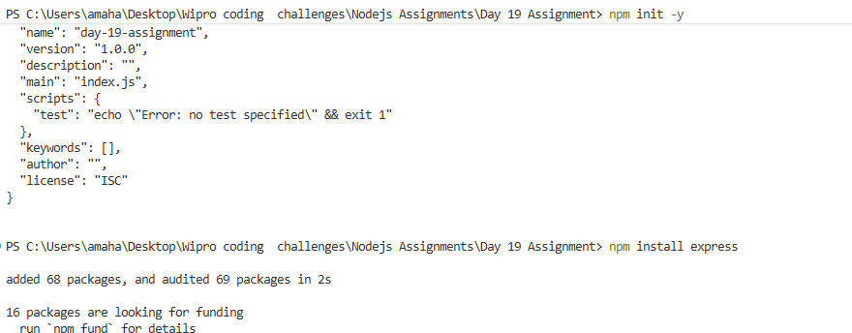
This screenshot shows the initialization of a new Node.js project and the installation of Express using npm.

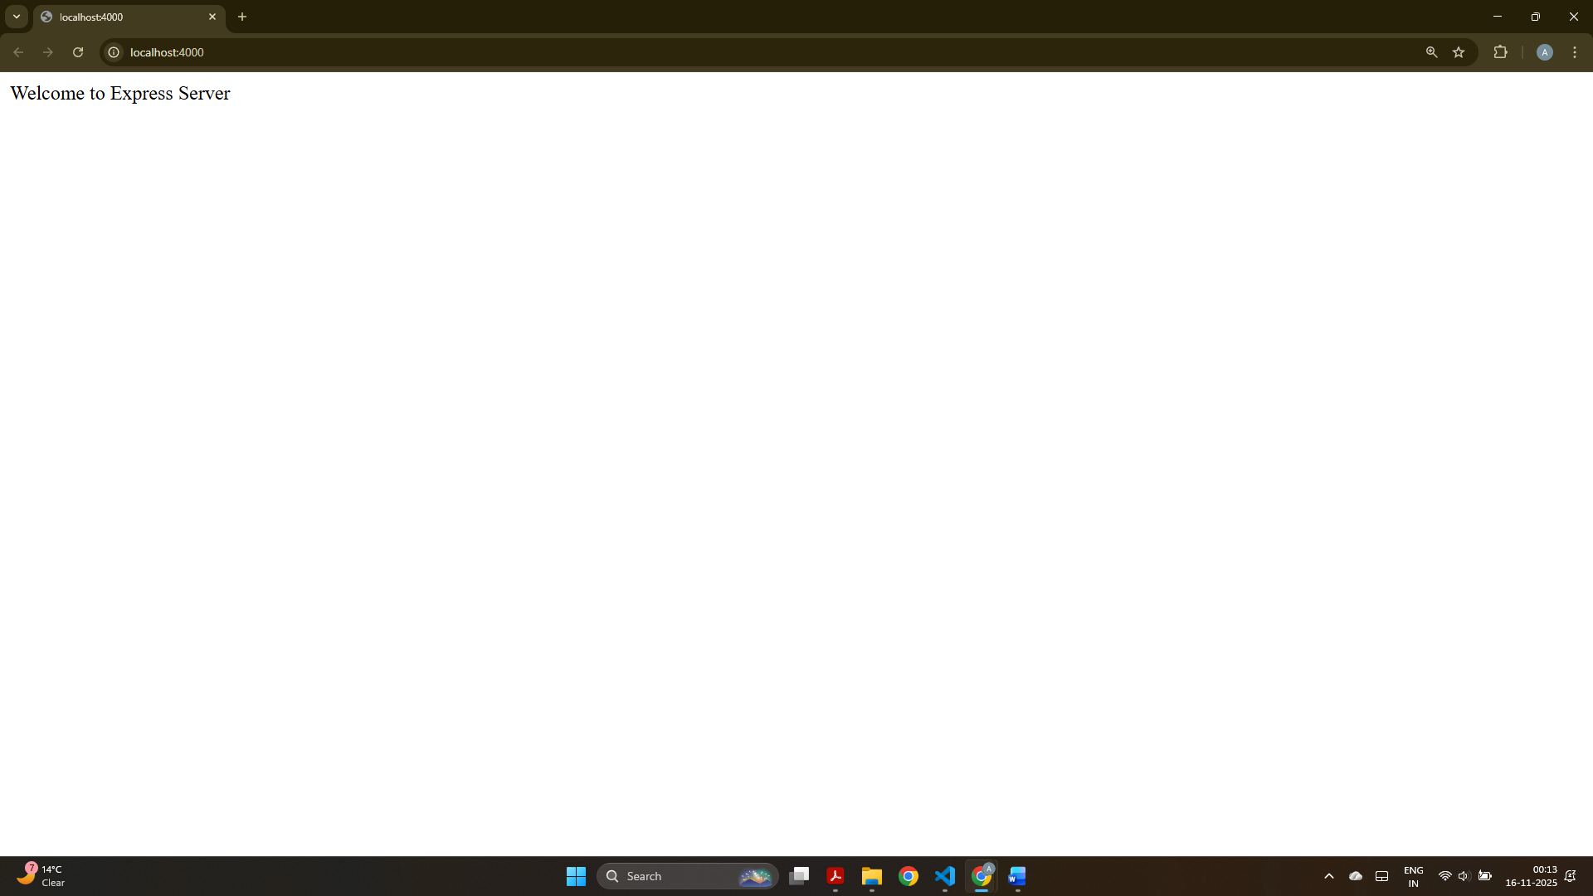
This screenshot displays the Express welcome message when accessing the root URL on port 4000.
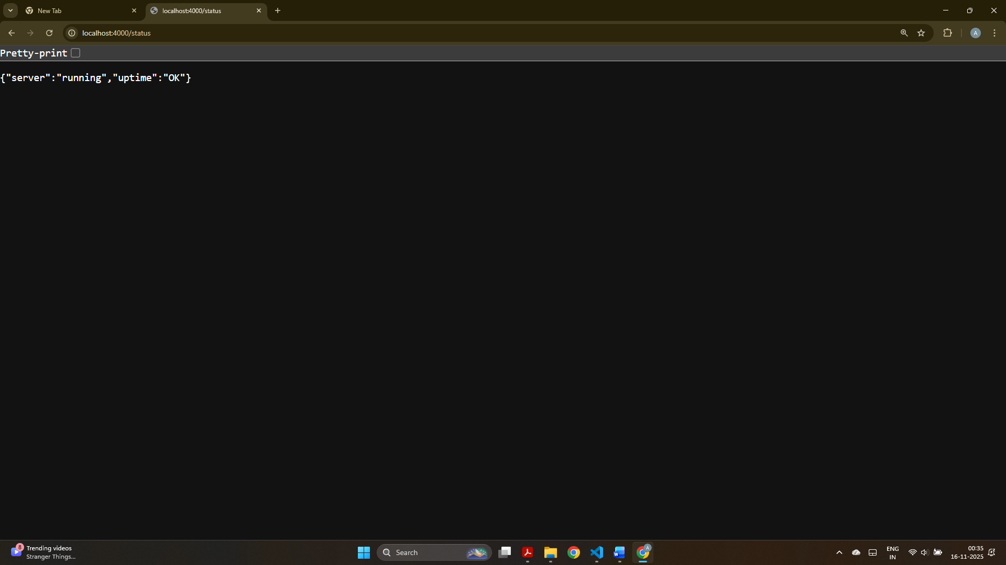
This screenshot shows the JSON server status response confirming the bonus route is working.

Challenge 2:
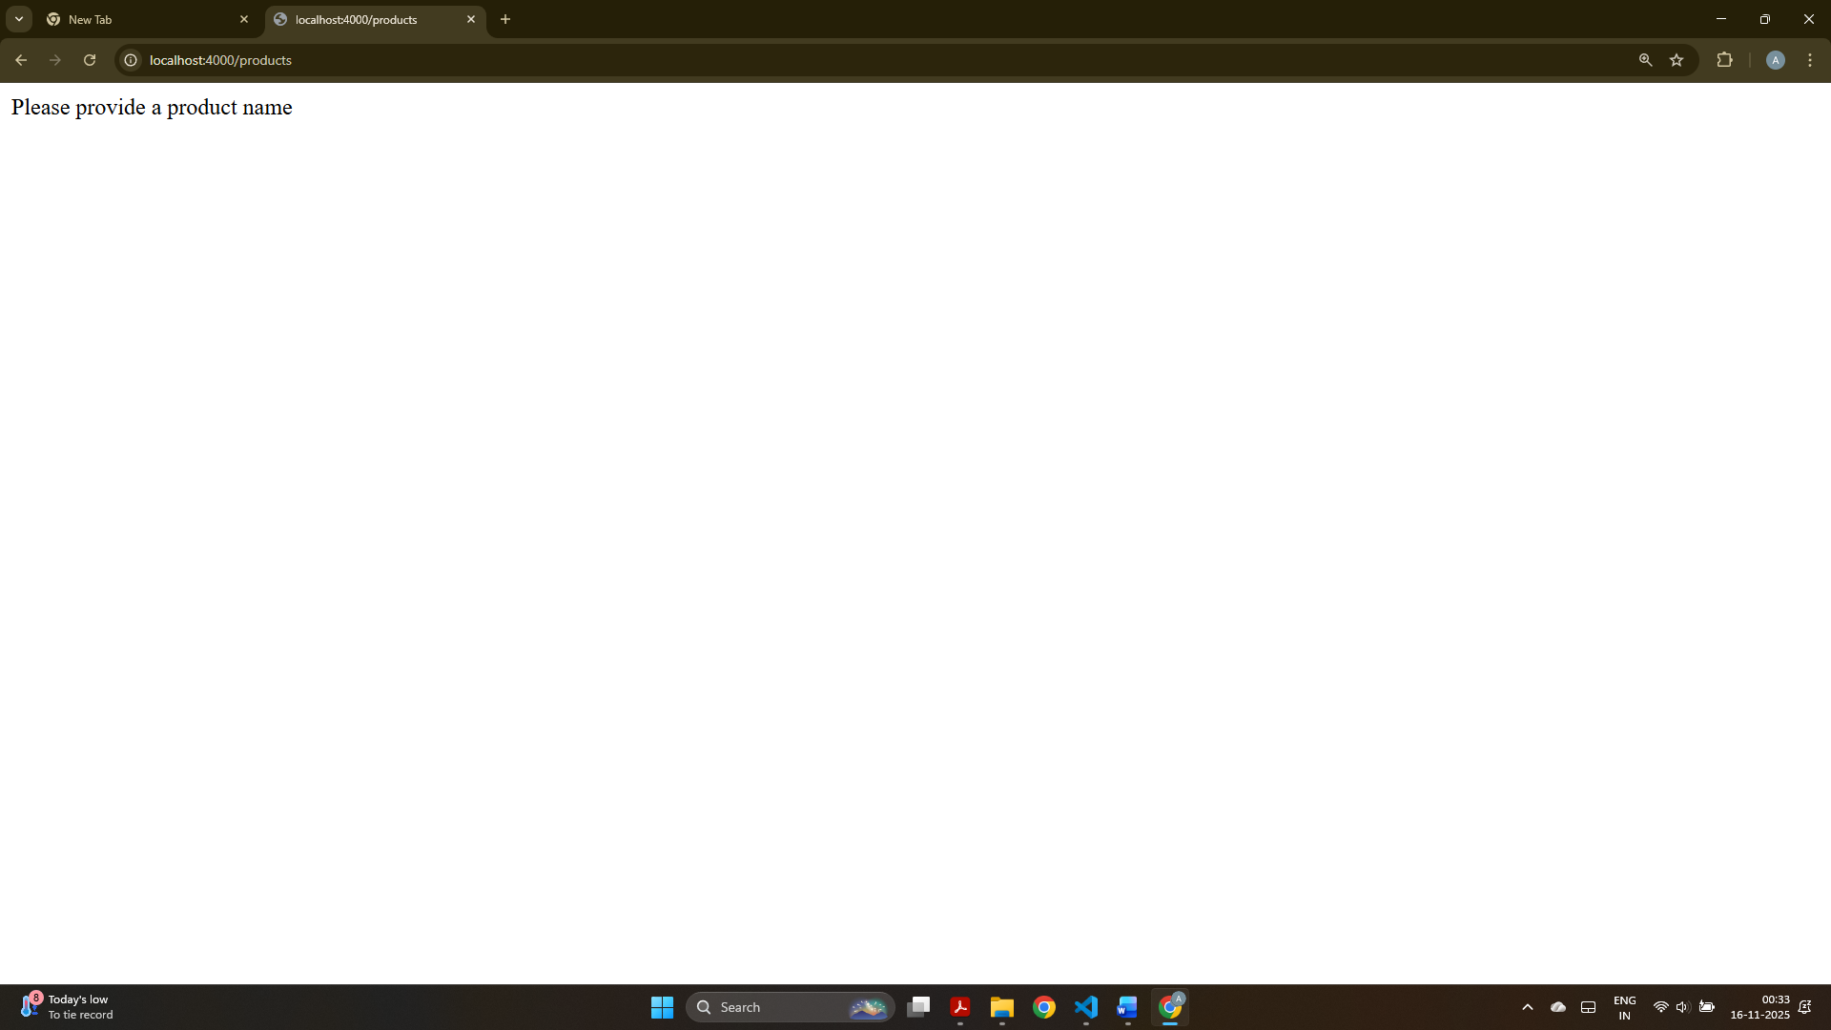
This screenshot shows the message asking the user to provide a product name when no query parameter is passed.
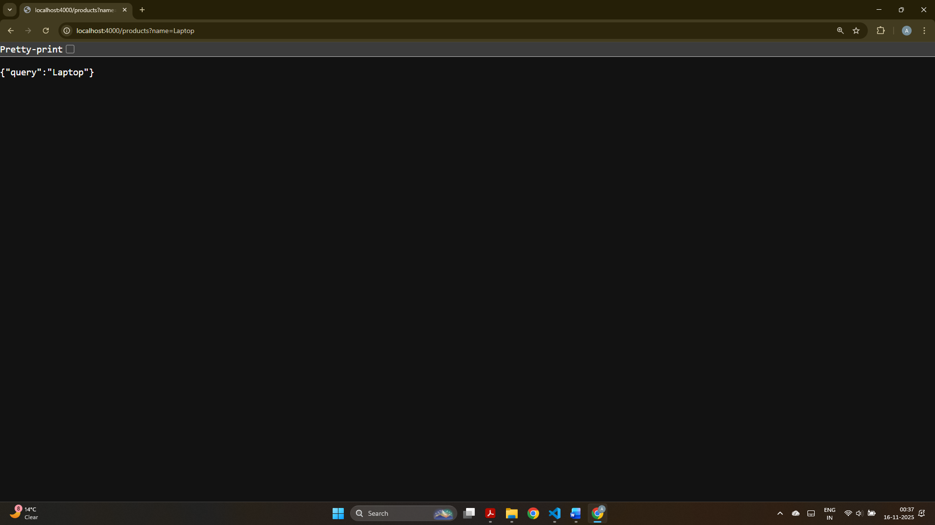
This screenshot displays the JSON output showing the product name received through the query parameter.

Challenge 3:
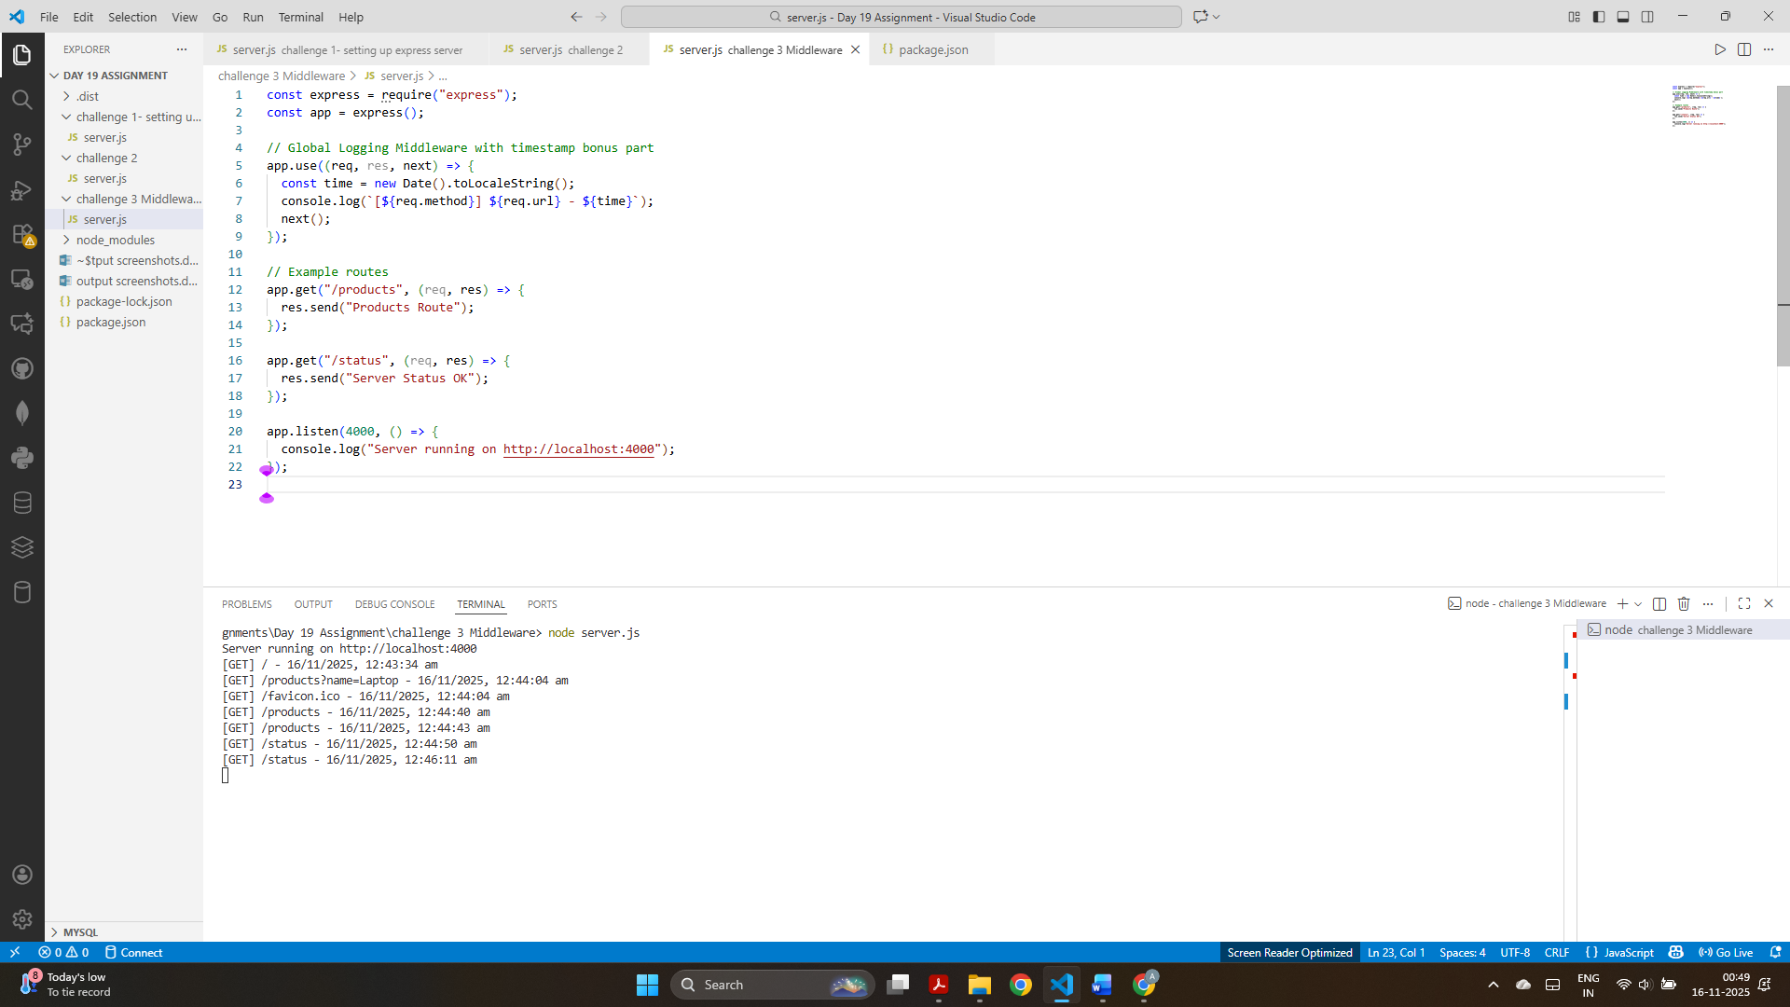
This screenshot shows console logs of all incoming requests along with timestamps, confirming global middleware is working.

Challenge 4:
GET All Books:
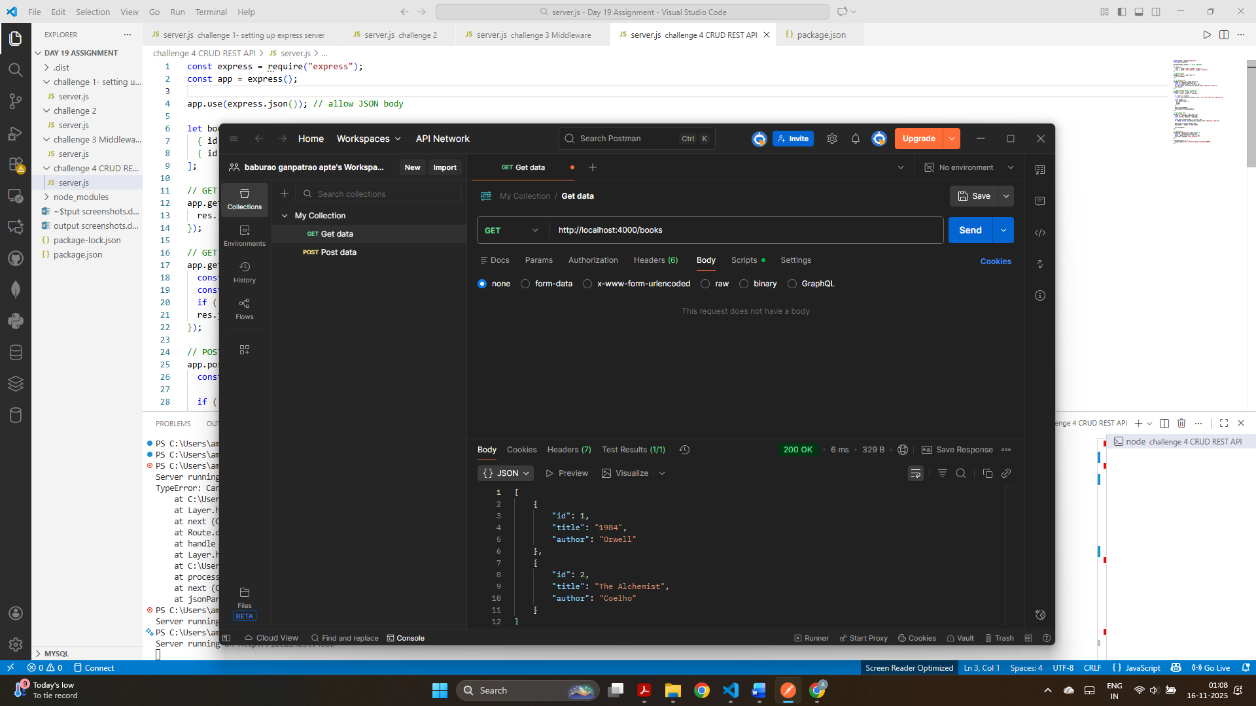

GET Book by id: 1
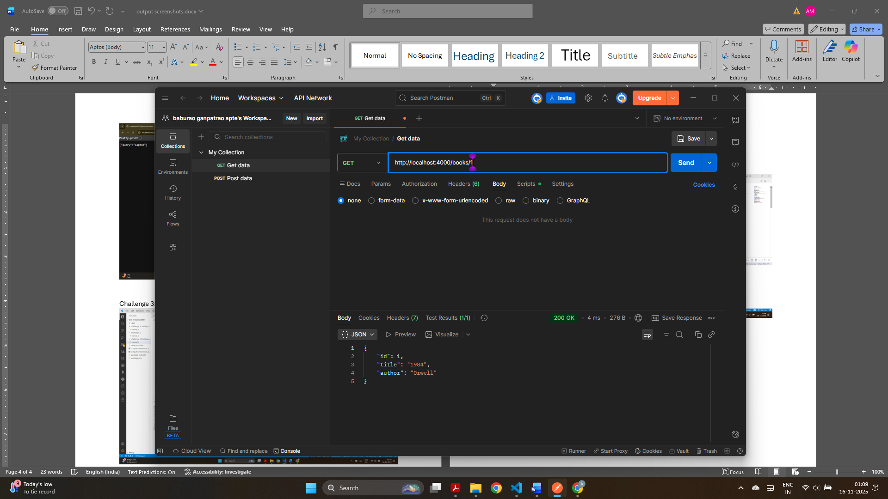

GET Book by id: 2
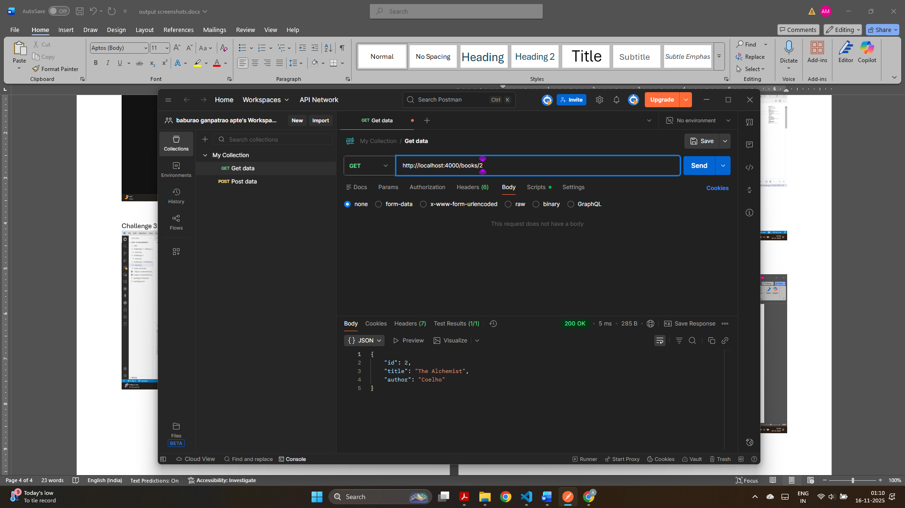

POST: New Book with id, title and author is added
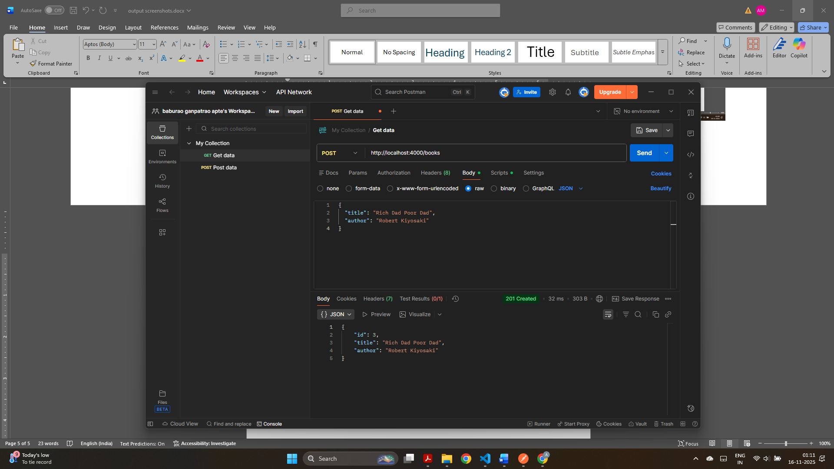

PUT: Updated book with id:2 from “title”: “The Alchemist” to “title”: “The Alchemist – Updated”
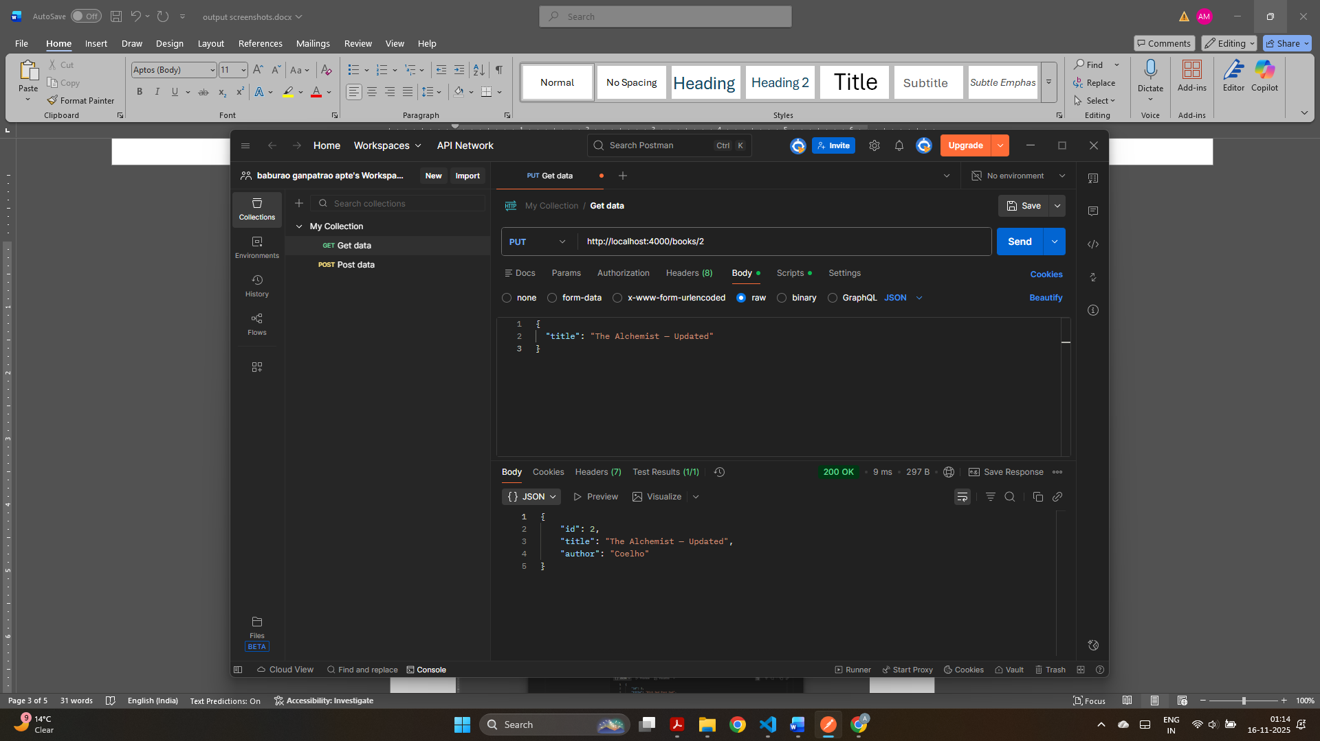

DELETE: book with id:1. It shows the message: Book deleted.
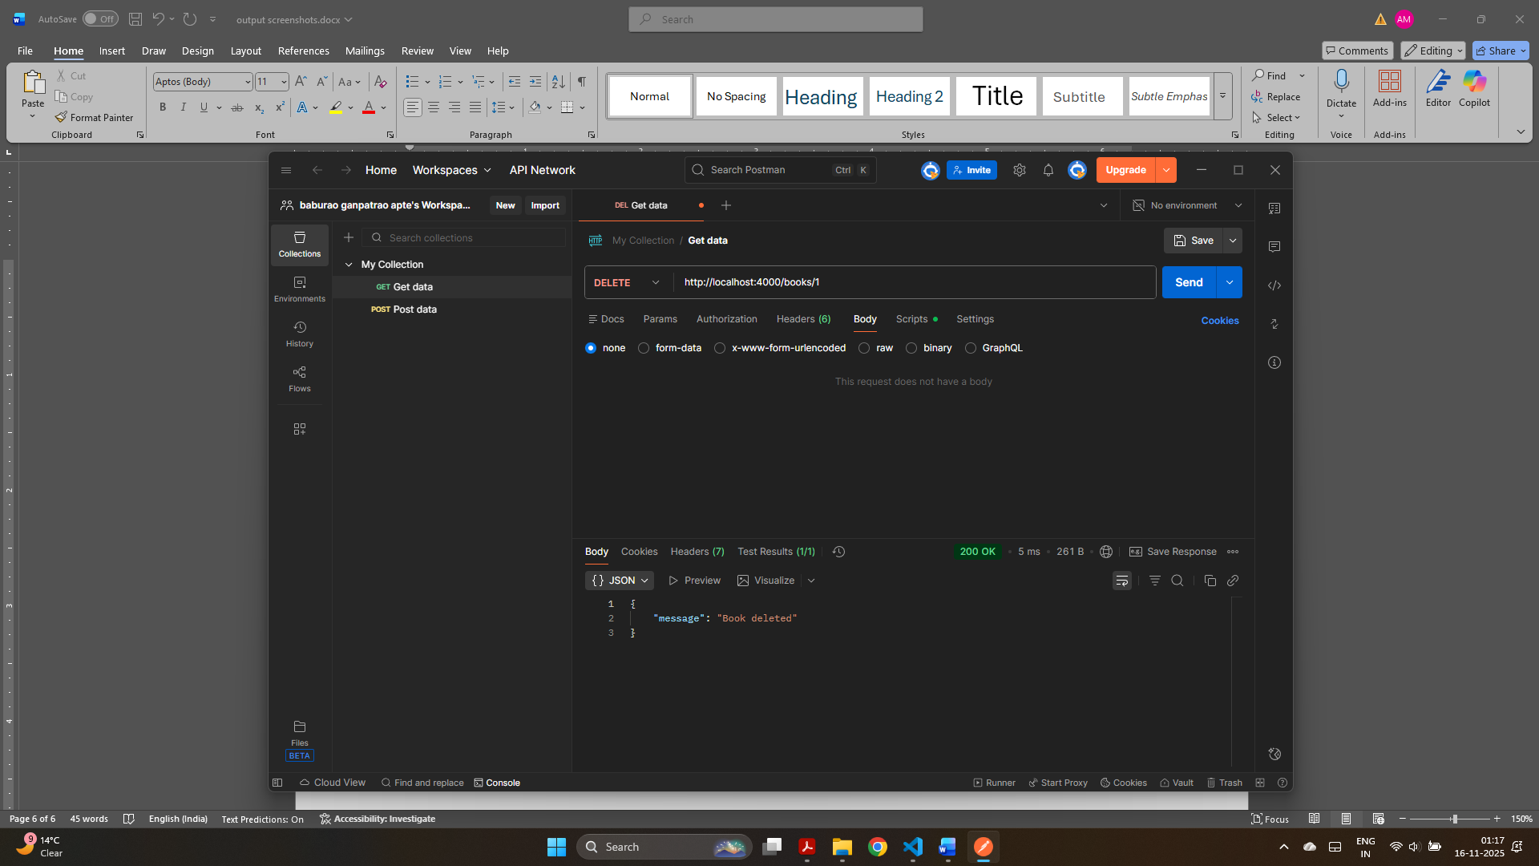

Challenge 5:
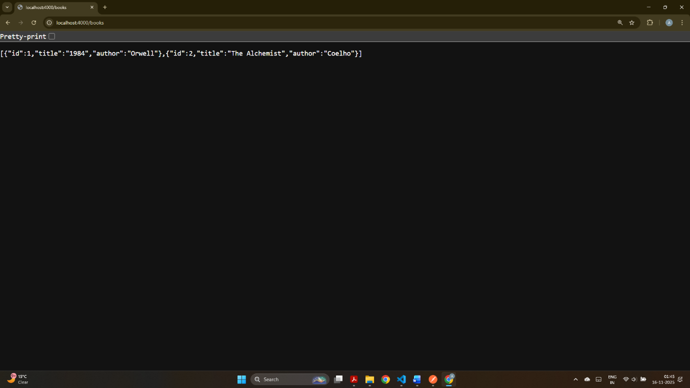
This screenshot shows the JSON list of books returned from the modularized route.

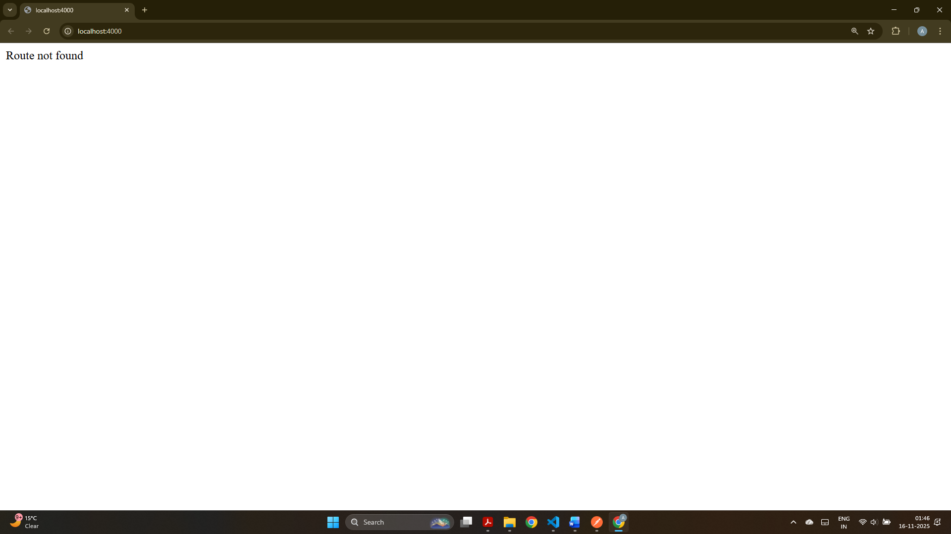
This screenshot shows the custom 404 message “Route not found” when visiting an undefined route.

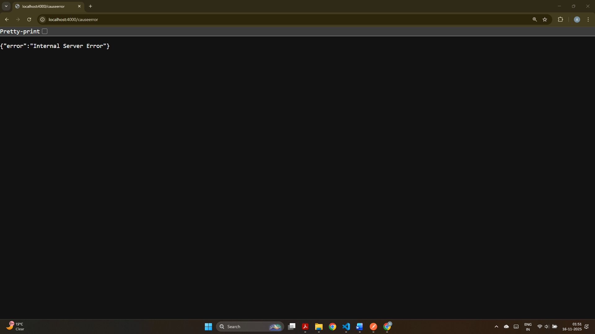
This screenshot confirms the centralized error handler is working by returning an “Internal Server Error” JSON response.

